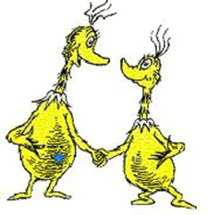
Name ________________________________________

Practice: Codominance and Incomplete Dominance
1. Practice setting up keys for the phenotypes listed in each set. Remember that the "medium" trait must always be heterozygous.
- Birds can be blue, white, or white with blue-tipped feathers.

- Flowers can be white, pink, or red.

- A Hoo can have curly hair, spiked hair, or a mix of both curly and spiked.

- A Sneech can be tall, medium, or short.

- A Bleexo can be spotted, black, or white.

2. Now, can you figure out in the above list, which of the letters represent codominant traits and which are incomplete.
Codominant _____________ Incompletely Dominant ________________
3. In Smileys, eye shape can be starred, circular, or a circle with a star. Write the genotypes for the pictured phenotypes


Show the cross between a star-eyed and a circle eyed.
What are the phenotypes of the offspring? ____________
What are the genotypes? __________

4. Show the cross between a circle-star eyed, and a circle eyed.
How many of the offspring are circle-eyed? ____________
How many of the offspring are circle-star eyed? ____________

5. Show the cross between two circle-star eyed.
How many of the offspring are circle-eyed? ____________
How many of the offspring are circle-star eyed? ____________
How many are star eyed? ____________

